Below is an example on how to select a static dropdown.

Generally if you see select tag in html then it is static dropdown

**import** java.time.Duration;

**import** org.openqa.selenium.By;

**import** org.openqa.selenium.By.ByCssSelector;

**import** org.openqa.selenium.WebDriver;

**import** org.openqa.selenium.WebElement;

**import** org.openqa.selenium.chrome.ChromeDriver;

**import** org.openqa.selenium.support.ui.Select;

**public** **class** Selenium1 {

**public** **static** **void** main(String[] args) **throws** InterruptedException {

// **TODO** Auto-generated method stub

//Below is the driver extension that is required to invoke the browser

System.*setProperty*("webdriver.chrome.driver", "E:\\Selenium\\chromedriver.exe");

//Invoking Browser

ChromeDriver driver =**new** ChromeDriver();

driver.get("https://rahulshettyacademy.com/dropdownsPractise/");

WebElement staticdrpdwn = driver.findElement(By.*id*("ctl00_mainContent_DropDownListCurrency"));

Select dropdown = **new** Select(staticdropdwn);

dropdown.selectByIndex(3);

System.***out***.println(dropdown.getFirstSelectedOption().getText());

dropdown.selectByVisibleText("AED");

System.***out***.println(dropdown.getFirstSelectedOption().getText());

dropdown.selectByValue("INR");

System.***out***.println(dropdown.getFirstSelectedOption().getText());

//driver.close();

}

}

Below is an example of dynamic dropdown. Its different to static because here the values is populated from javascript or back end

**import** org.openqa.selenium.By;

**import** org.openqa.selenium.WebElement;

**import** org.openqa.selenium.chrome.ChromeDriver;

**import** org.openqa.selenium.support.ui.Select;

**public** **class** Selenium2 {

**public** **static** **void** main(String args[]) **throws** InterruptedException{

//Below is the driver extension that is required to invoke the browser

System.*setProperty*("webdriver.chrome.driver", "E:\\Selenium\\chromedriver.exe");

//Invoking Browser

ChromeDriver driver =**new** ChromeDriver();

driver.get("https://rahulshettyacademy.com/dropdownsPractise/");

driver.get("http://spicejet.com");

driver.findElement(By.*id*("ctl100_mainContent_ddl_organization_CTXT")).click();

//for dynamic dropdown

driver.findElement(By.*xpath*("//a[@value='BLR']")).click();

Thread.*sleep*(2000);

driver.findElement(By.*xpath*("/(/a[@value='MAA'])[2]")).click();

//driver.close();

}

}

Below is an example where we are sending values to an Autosuggestive text box

**import** java.util.List;

**import** org.openqa.selenium.By;

**import** org.openqa.selenium.WebElement;

**import** org.openqa.selenium.chrome.ChromeDriver;

**import** org.openqa.selenium.support.ui.Select;

**public** **class** Selenium2 {

**public** **static** **void** main(String args[]) **throws** InterruptedException{

//Below is the driver extension that is required to invoke the browser

System.*setProperty*("webdriver.chrome.driver", "E:\\Selenium\\chromedriver.exe");

//Invoking Browser

ChromeDriver driver =**new** ChromeDriver();

driver.get("https://rahulshettyacademy.com/dropdownsPractise/");

driver.findElement(By.*id*("autosuggest")).sendKeys("ind");

Thread.*sleep*(3000);

List<WebElement> options =driver.findElements(By.*cssSelector*("li[class='ui-menu-item'] a"));

**for**(WebElement option :options)

{

**if**(option.getText().equalsIgnoreCase("India"))

{

option.click();

**break**;

}

}

}

}

Below is an example of selecting a checkbox and also checking if checkbox is selected or not

**import** java.util.List;

**import** org.openqa.selenium.By;

**import** org.openqa.selenium.WebElement;

**import** org.openqa.selenium.chrome.ChromeDriver;

**import** org.openqa.selenium.support.ui.Select;

**import** org.testng.Assert;

**public** **class** Selenium2 {

**public** **static** **void** main(String args[]) **throws** InterruptedException{

//Below is the driver extension that is required to invoke the browser

System.*setProperty*("webdriver.chrome.driver", "E:\\Selenium\\chromedriver.exe");

//Invoking Browser

ChromeDriver driver =**new** ChromeDriver();

driver.get("http://spicejet.com"); //URL in the browser

System.***out***.println((driver.findElement(By.*cssSelector*("input[id*='SeniorCitizenDiscount']")).isSelected()));

driver.findElement(By.*cssSelector*("input[id*='SeniorCitizenDiscount']")).click(

System.***out***.println(driver.findElement(By.*cssSelector*("input[id*='SeniorCitizenDiscount']")).isSelected());

}

}

Below is an example where instead of checking whether selected true or not over console or assigned a boolean and checking using if condition we can also use a TestNG Assert.assert True or assert False. Basically if assert.true means it thinks that statement will be true and if is true it passes otherwise it fails and in assert.false it thinks that statement will be false and if it is false it passes otherwise it fails

**import** java.util.List;

**import** org.openqa.selenium.By;

**import** org.openqa.selenium.WebElement;

**import** org.openqa.selenium.chrome.ChromeDriver;

**import** org.openqa.selenium.support.ui.Select;

**import** org.testng.Assert;

**public** **class** Selenium2 {

**public** **static** **void** main(String args[]) **throws** InterruptedException{

//Below is the driver extension that is required to invoke the browser

System.*setProperty*("webdriver.chrome.driver", "E:\\Selenium\\chromedriver.exe");

//Invoking Browser

ChromeDriver driver =**new** ChromeDriver();

driver.get("http://spicejet.com"); //URL in the browser

Assert.*assertFalse*(driver.findElement(By.*cssSelector*("input[id*='SeniorCitizenDiscount']")).isSelected());

driver.findElement(By.*cssSelector*("input[id*='SeniorCitizenDiscount']")).click();

System.***out***.println(driver.findElement(By.*cssSelector*("input[id*='SeniorCitizenDiscount']")).isSelected());

Assert.*assertTrue*(driver.findElement(By.*cssSelector*("input[id*='SeniorCitizenDiscount']")).isSelected());

}

}

Below is an example to select current calendar date, basically we had only selected the active state field that means the current date

**import** java.util.List;

**import** org.openqa.selenium.By;

**import** org.openqa.selenium.WebElement;

**import** org.openqa.selenium.chrome.ChromeDriver;

**import** org.openqa.selenium.support.ui.Select;

**import** org.testng.Assert;

**public** **class** Selenium2 {

**public** **static** **void** main(String args[]) **throws** InterruptedException{

//Below is the driver extension that is required to invoke the browser

System.*setProperty*("webdriver.chrome.driver", "E:\\Selenium\\chromedriver.exe");

//Invoking Browser

ChromeDriver driver =**new** ChromeDriver();

driver.get("https://rahulshettyacademy.com/dropdownsPractise/"); //URL in the browser

//clicking calender picker option

driver.findElement(By.*xpath*("//button[@class='ui-datepicker-trigger']")).click();

//selecting current date

driver.findElement(By.*cssSelector*(".ui-state-default.ui-state-highlight.ui-state-active")).click();

}

}

Below is an example where we are checking an UI Element (Calendar) is enabled or not say for one way trip return calendar should be disabled and for two way it should be enabled

But in below return is also enabled due to modern browser features. Will see in next example how to handle it

**import** java.util.List;

**import** org.openqa.selenium.By;

**import** org.openqa.selenium.WebElement;

**import** org.openqa.selenium.chrome.ChromeDriver;

**import** org.openqa.selenium.support.ui.Select;

**import** org.testng.Assert;

**public** **class** Selenium2 {

**public** **static** **void** main(String args[]) **throws** InterruptedException{

//Below is the driver extension that is required to invoke the browser

System.*setProperty*("webdriver.chrome.driver", "E:\\Selenium\\chromedriver.exe");

//Invoking Browser

ChromeDriver driver =**new** ChromeDriver();

driver.get("https://rahulshettyacademy.com/dropdownsPractise/"); //URL in the browser

//clicking calender picker option

driver.findElement(By.*xpath*("//button[@class='ui-datepicker-trigger']")).click();

System.***out***.println(driver.findElement(By.*xpath*("//input[@id='ctl00_mainContent_view_date2']")).isEnabled());

//driver.findElement(By.xpath("//input[@id='ctl00_mainContent_view_date2']")).click();

System.***out***.println(driver.findElement(By.*xpath*("//input[@id='ctl00_mainContent_view_date2']")).isEnabled());

}

}

Below is an example now here we are checking from html attributes how is before enabled and after enabled and based on that we are getting those attributes in selenium and handling with condition

**import** java.util.List;

**import** javax.swing.text.Style;

**import** org.openqa.selenium.By;

**import** org.openqa.selenium.WebElement;

**import** org.openqa.selenium.chrome.ChromeDriver;

**import** org.openqa.selenium.support.ui.Select;

**import** org.testng.Assert;

**public** **class** Selenium2 {

**public** **static** **void** main(String args[]) **throws** InterruptedException{

//Below is the driver extension that is required to invoke the browser

System.*setProperty*("webdriver.chrome.driver", "E:\\Selenium\\chromedriver.exe");

//Invoking Browser

ChromeDriver driver =**new** ChromeDriver();

driver.get("https://rahulshettyacademy.com/dropdownsPractise/"); //URL in the browser

//clicking calender picker option

driver.findElement(By.*xpath*("//button[@class='ui-datepicker-trigger']")).click();

System.***out***.println(driver.findElement(By.*xpath*("//input[@id='ctl00_mainContent_view_date2']")).isEnabled());

//for the round way calendar checking

//driver.findElement(By.xpath("//div[@class='picker-second']")).getAttribute("style");

System.***out***.println(driver.findElement(By.*xpath*("//div[@class='picker-second']")).getAttribute("style"));

**if**(driver.findElement(By.*xpath*("//div[@class='picker-second']")).getAttribute("style").contains("0.5")) {

System.***out***.println("It's in disabled");

Assert.*assertTrue*(**true**);

}**else**

//failing the condition

Assert.*assertTrue*(**false**);

}

}

Below is an example on how to manage the alerts on webpage. Generally the alerts are not a part of HTML but it’s of web browser one’s. We can se switchTo().alert() and accept or cancel it

**import** java.util.List;

**import** javax.swing.text.Style;

**import** org.openqa.selenium.By;

**import** org.openqa.selenium.WebElement;

**import** org.openqa.selenium.chrome.ChromeDriver;

**import** org.openqa.selenium.support.ui.Select;

**import** org.testng.Assert;

**public** **class** Selenium2 {

**public** **static** **void** main(String args[]) **throws** InterruptedException{

//Below is the driver extension that is required to invoke the browser

System.*setProperty*("webdriver.chrome.driver", "E:\\Selenium\\chromedriver.exe");

//Invoking Browser

ChromeDriver driver =**new** ChromeDriver();

driver.get("https://rahulshettyacademy.com/AutomationPractice/"); //URL in the browser

driver.findElement(By.*cssSelector*("input[id='name']")).sendKeys("Ramu");

driver.findElement(By.*xpath*("//input[@class='btn-style']")).click();

System.***out***.println(driver.switchTo().alert().getText());

driver.switchTo().alert().accept();

//dismiss if alert provides that dismiss option as well

//driver.switchTo().alert().dismiss();

}

}

How to format and align the code in Eclipse – Ctrl + Shift + F

Naming Conventions in defining class, variable and methods – camelCase

Below is an example where the button (ADD TO CART doesn’t have any specific class name or id it is bit generic) and in this case how to click that button for specific items and also how to write the code generic so that next day if you want to click button for other items then there should no major code change but add that items in code

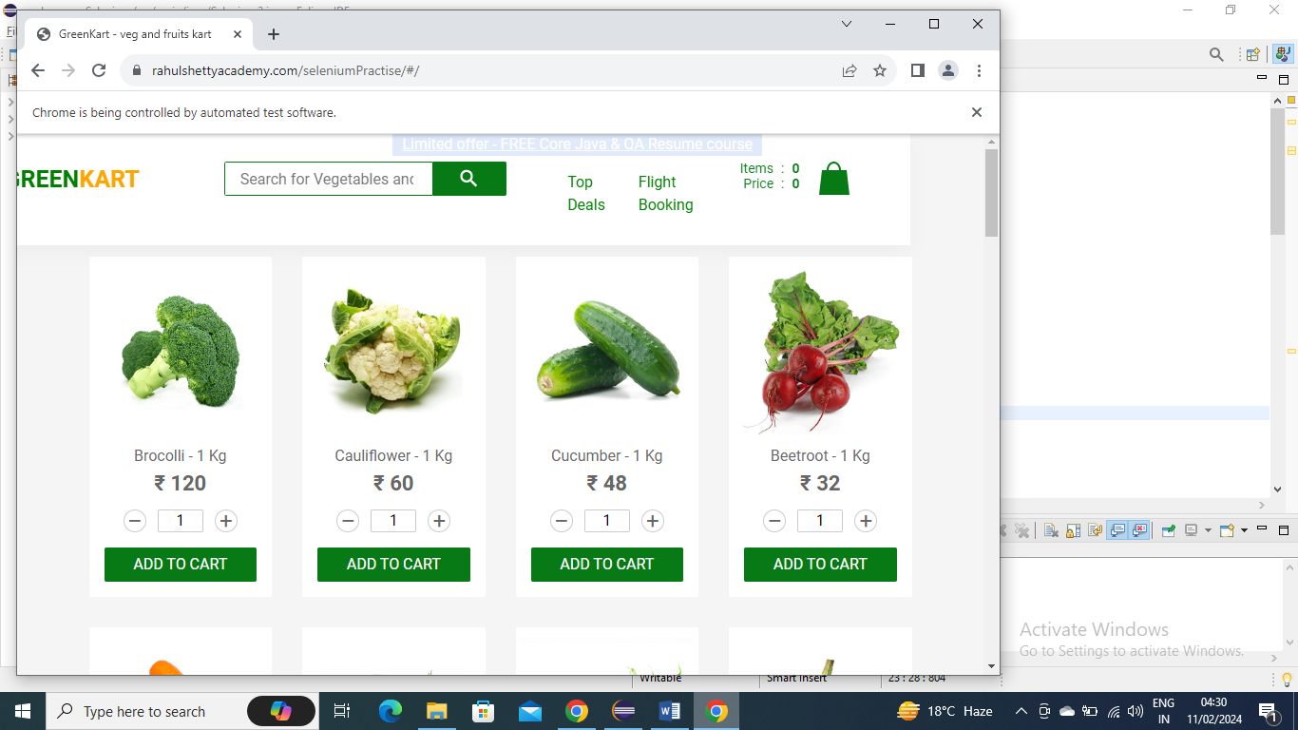

**import** java.util.Arrays;

**import** java.util.List;

**import** javax.swing.text.Style;

**import** org.openqa.selenium.By;

**import** org.openqa.selenium.WebDriver;

**import** org.openqa.selenium.WebElement;

**import** org.openqa.selenium.chrome.ChromeDriver;

**import** org.openqa.selenium.support.ui.Select;

**import** org.testng.Assert;

**public** **class** Selenium2 {

**public** **static** **void** main(String args[]) **throws** InterruptedException {

// Below is the driver extension that is required to invoke the browser

System.*setProperty*("webdriver.chrome.driver", "E:\\Selenium\\chromedriver.exe");

// Invoking Browser

ChromeDriver driver = **new** ChromeDriver();

String[] itemsNeeded = { "Cucumber", "Brocolli", "Beetroot" };

driver.get("https://rahulshettyacademy.com/seleniumPractise/");

Thread.*sleep*(3000);

*addItems*(driver, itemsNeeded);

}

**public** **static** **void** addItems(WebDriver driver, String[] itemsNeeded)

{

**int** j = 0;

List<WebElement> products = driver.findElements(By.*cssSelector*("h4.product-name"));

**for** (**int** i = 0; i < products.size(); i++)

{

// Brocolli - 1 Kg

// Brocolli, 1 kg

String[] name = products.get(i).getText().split("-");

String formattedName = name[0].trim();

// format it to get actual vegetable name

// convert array into array list for easy search

// check whether name you extracted is present in arrayList or not-

List itemsNeededList = Arrays.*asList*(itemsNeeded);

**if** (itemsNeededList.contains(formattedName))

{

j++;

// click on Add to cart

driver.findElements(By.*xpath*("//div[@class='product-action']/button")).get(i).click();

**if** (j == itemsNeeded.length)

{

**break**;

}

}

}

}

}